Feudal Japan Vocabulary Name:
Block:
Han-

Daiymo-

Samurai-

Shogun-

Uji -

Koku-

Be-

Amaterasu-

Bushido-

Emperor-

Shiro-

Wa-

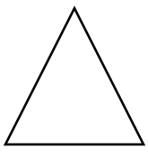
Directions: Just like in Feudal Europe there is a class system. Using the pyramid below, draw the relationship between the social classes of Feudal Japan. Draw arrows to demonstrate what each relationship owes one another (taxes, protection, loyalty, food)

