World History
Ms. Lukas
Study Guide: Paleolithic Man,
Neolithic Revolution and Mesopotamian Civilization

Identification: Who? What? Where? Why Important?

- 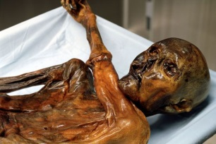

- 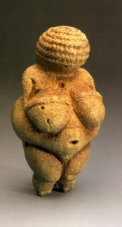

- 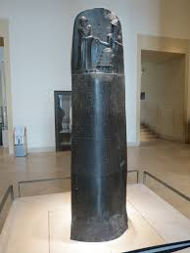

- 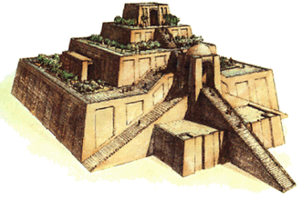
People, Places, Events, Concepts

Paleolithic

Mesolithic

Neolithic

Neolithic Revolution

Carbon Dating

Hominid

Lucy

Australopithecus

Homo Erectus

Neanderthals

Homo Sapiens Sapiens

“Out of Africa” Theory

Catal Huyuk

Jericho

Mesopotamia

Indus Civilization

Shang Dynasty

Sumer

Gilgamesh

Babylonia

Assyria

Polytheism

Sargon the Great

Ashurnasirpal II

Sennacherib

Esarhaddon

Ashurbanipal

Neo Babylonian Empire

Nabopolassar

Nebuchadnezzar II

Babylonian Captivity

Essential Questions

What was the role of women and men during the Paleolithic Age?

How did our ideas of human sexuality develop during the Paleolithic Age?

Explain, in basic terms, what life was like for man during the Paleolithic Age?

What role did fire have in the development of man?

What did cave art of early man depict and tell us?

How was the Neolithic Revolution a blessing and a curse for mankind? (think of Jared Diamond)

Where in the world did the earliest Neolithic communities develop? (Four Main Areas)

What are the six characteristics of civilization?

How did the Tigris and Euphrates play an important role in the development of Mesopotamian civilization? (Think about the 6 characteristics of civilization)

How did religion play a role in Mesopotamian civilization? (think of Gilgamesh)

What were the major accomplishments of the Sumerians?

What did Hammurabi’s code tell us about ancient Babylonian society?

How did Assyria come to dominate the “four corners of the known universe”?

Why was the development of cuneiform important for the Mesopotamians?

Who were the Phoenicians and why were they significant?

Long-answer Unit Questions
Formulate some organized plans that will help you answer the two unit questions. Outline a few ways so far that you could answer these questions. These two questions will most likely be long-answer (not essay) questions. There is no one right answer! You will get points based on your in-class examples and ability to provide CLEAR, SPECIFIC (and good “so what?”) analysis. We have done examples in class – study those also!

Unit question 1) What are some of the challenges historians face when constructing history?

Unit question 2) Why are some things in history preserved over time, and others are not?

